Your Water System – Operation and Maintenance

With each issue of the Trail News, we hope to dive into a topic and paint a picture of your water system and how we provide quality, reliable water service to you. Last issue, we provided an overview of our water system, including our planning efforts and how we finance the work.

This issue, we are focusing on what it takes to operate and maintain our water system, to keep your water flowing. As with anything, age and condition play a factor in how well it can perform. Regular maintenance is critical to extend the life and performance of the equipment.

Oregon City has the unique distinction of being the first incorporated city west of the Rocky Mountains. It was founded in 1829 and incorporated in 1844. As a result, we have some of the oldest infrastructure in the region. About five years ago, crews were replacing an old steel pipe in Linn Avenue and noticed the pipe was dated 1890!

Over the years, the city has grown and so has the water system. The system is now comprised of over 150 miles of pipe, ranging in diameter from 2 inches to 30 inches. Pipe materials vary as well, including ductile iron, cast iron, steel, galvanized, and PVC. While the pipes get the water where it needs to be, that is just one component of the system. In addition, we have 5 booster pumps that lift the water to 5 reservoirs located throughout the city that provide a total of 18.25 million gallons of storage. Our 19 pressure-reducing valves bring down the pressure to a safe level before the water reaches any plumbing fixtures inside a home or business. Too much water pressure can cause many plumbing problems, so it is very important to keep the water pressure under control. All these components of our water system help ensure that you have the right amount of water, at a safe pressure, when you need it.

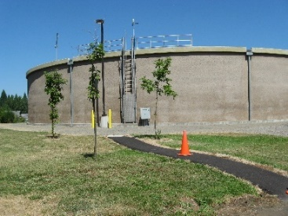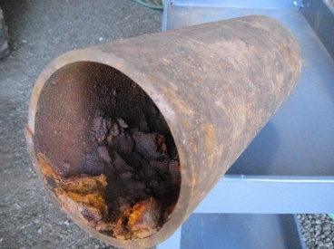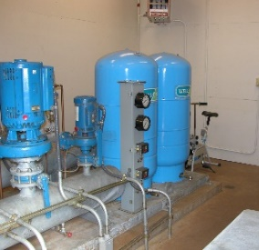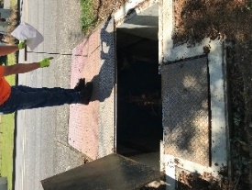

Ensuring our fire hydrants work properly and water in pipes is fresh requires “flushing” of the lines. Each year, the Water Operations crew flushes 50 miles of pipe, or one-third of our system. Flushing allows the moving water to pick up any sediment that may have formed on the bottom of the pipe, flushing it out of the system. Crews work with customers to not affect their private piping by temporarily turning off their water supply during flushing activity.

When you pay your water bill, you help support operation and maintenance of our water system. Your Water Operations staff work hard year around to ensure you have safe, reliable water. On any given day, your Water Operations crew may be performing maintenance on our reservoirs, pump stations, water lines, meters, and fire hydrants. As new water lines are installed or old lines are replaced, Water Operations is there to ensure the lines have been sterilized to provide clean drinking water, and that they are properly connected to our system for safety and reliability.

Always Working to Improve Service
The Water Operations crew regularly discusses how they can do things differently or learn from past experiences. A prime example of this innovation was how they flushed the fire hydrants. In the past, flushing the hydrants sent water into the streets and then eventually into the drain. This not only flooded the street temporarily, but it picked up oils and debris in the street that impacted water quality of the water being released. A Water Operations crew member at the time, Jake Ashenberner, developed a device to allow the flushed water to be funneled through a hydrant mounted on the truck, directly into the sewer. Great job Jake!

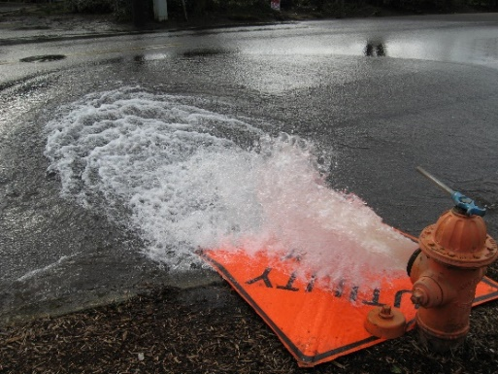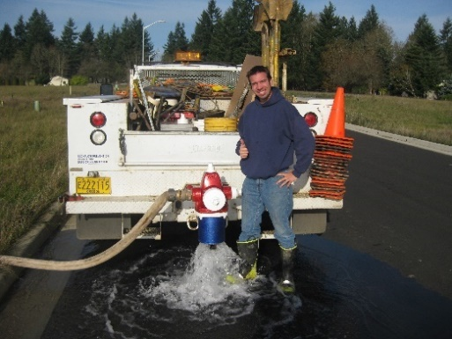
Flushing hydrants before and after using crew-designed new system

This is just one example of how the Water Operations crew continues to work as a team to make sure they are providing the best service to you, our customers.

