Resiliency
“Resiliency” is defined by Merriam-Webster as “the ability to recover from or adjust easily to adversity or change.” This past year we have seen our share of adversity and change with a pandemic, wildfires, and more recently, the ice storm.

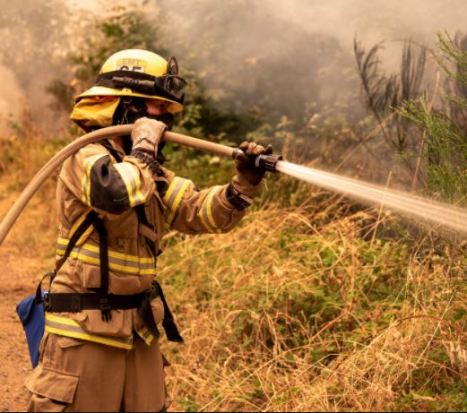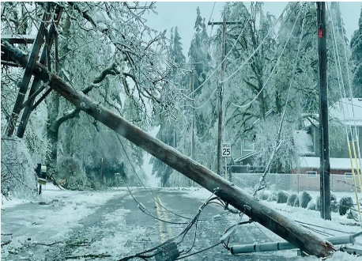

These events have shown us how resilient we can be as individuals and as a community. They have also shown us where we need to be better prepared to respond and rebound quicker. While we were able to keep water flowing during the ice storm using our back-up generators, we still have improvements to make to better prepare us for unexpected events. The City is working to ensure our water system is resilient through capital improvements that will:
- provide more storage with two new reservoirs;
- improve our ability to move water safely to the reservoirs;
- provide redundancy in the system by ensuring that areas have two routes for water to flow in case of a break in one;
- prevent pressure issues by replacing aging pressure-relief valves;
- strengthen our water system to prevent failure and interruption of water service by replacing aging water lines and making seismic improvements; and
- provide overall improvement in water capacity, pressure, and ability to move the water where it needs to go to improve our ability to fight fires.

Funding of these improvements is critical to ensure that we can provide quality, reliable water to our customers now and in the future – even after a major event. Funding sources for our water system come from water system development charges (WSDC) and water rates. The City recently adopted an increase in the WSDCs that will allow the City to collect fees from development to pay the cost of improvements needed to support growth. The new rates can be found on the City’s website: System Development Charges. These increases go into effect July 1, 2021.

The second component of funding is from our water rates. Rate increases can be minimized by taking on debt or financing project costs over a period of time. In 1998, the City put into place provisions that require voter approval for taking on debt and rate increases greater than 3%. To support the needed improvements, water rates will need to increase more than the 3% limit set by the Charter. As a result, a ballot measure will be prepared for voters to consider in the 2021 fall election. Under consideration will be the approval of a debt financing option that will allow a lower rate increase. More information for the upcoming ballot measure will be shared with the community as it becomes available.

If approved, the water rate increase, combined with the increased WSDCs, will provide the needed funding to strengthen and improve our water system to better meet the needs of our community now and in the future. Together we can improve our resiliency.

