Trillium Park Drive Neighborhood
Landslide Update Meeting
February 24, 2017
6:00 PM
City of Oregon City – City Hall
625 Center Street
Oregon City, Oregon

Agenda

WELCOME & INTRODUCTIONS – Tony Konkol
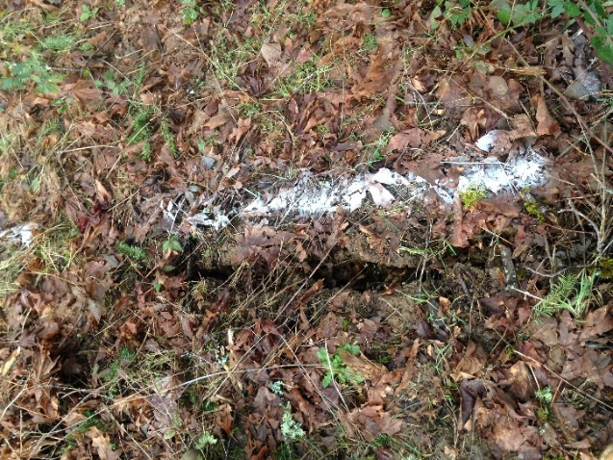

MEETING OVERVIEW – John Lewis

SITE STATUS – Aleta Froman-Goodrich, Tim Pfeiffer & Mike Marshall

SITE ASSESSMENT INTENT – Aleta Froman-Goodrich, Tim Pfeiffer &
Mike Marshall

REFERENCE RESOURCES – John Lewis

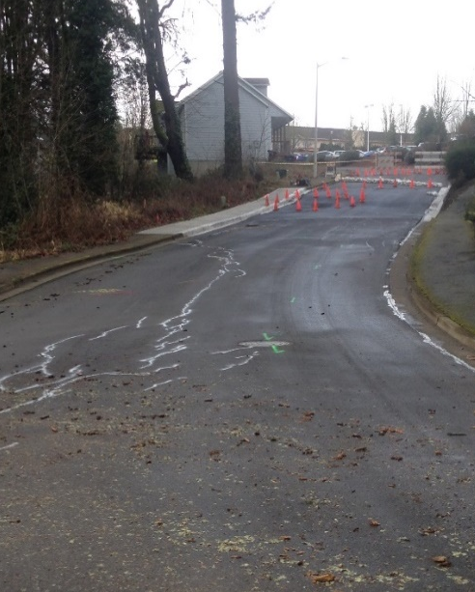
QUESTIONS?

City Staff:
Tony Konkol, City Manager
John Lewis, P.E., Public Works Director
Laura Terway, AICP, Community Development Director
Aleta Froman-Goodrich, P.E., City Engineer
Mike Roberts, Building Official

Non-City Staff:
Tim Pfeiffer, P.E., G.E., Foundation Engineering, Inc.
Mike Marshall, C.E.G., Geotechnical Resources, Inc.
Oscar Ramos, Battalion Chief, Clackamas Fire District #1
Greg Ramirez, Emergency Manager, Clackamas Fire District #1

 | 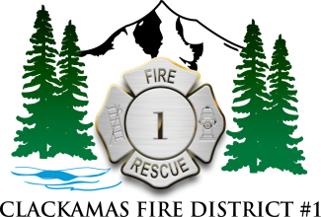 |  | 

