Website: https://online.orcity.org/EnerGov_prod/SelfService#/login
Account Registration
Please register an account with a valid email that will be linked to your permit records. Registration can also be found under the “Home” Tab.
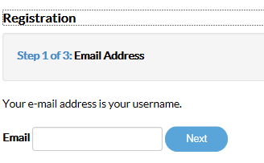
Input email address and select “Next”
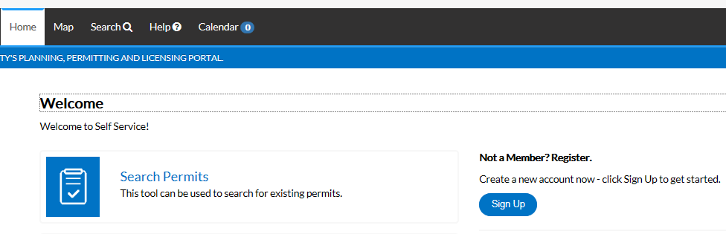
A notification will auto populate asking you to check your email. Log in to your email account to move on to the next step of the registration process.
The email will come from: permitnotification@orcity.org. Check your junk or spam email if you have not received the email. Select the “Confirm” link.
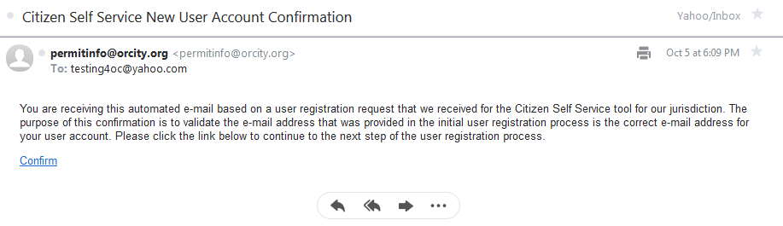
Once confirmed, you will be directed back to the Citizen Self Service Portal to complete your registration. Select “Register”.
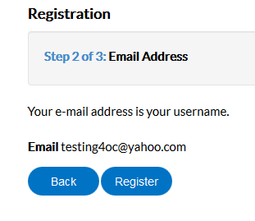
Example
Personal Info, Password and Contact Address Information must be completed to proceed. 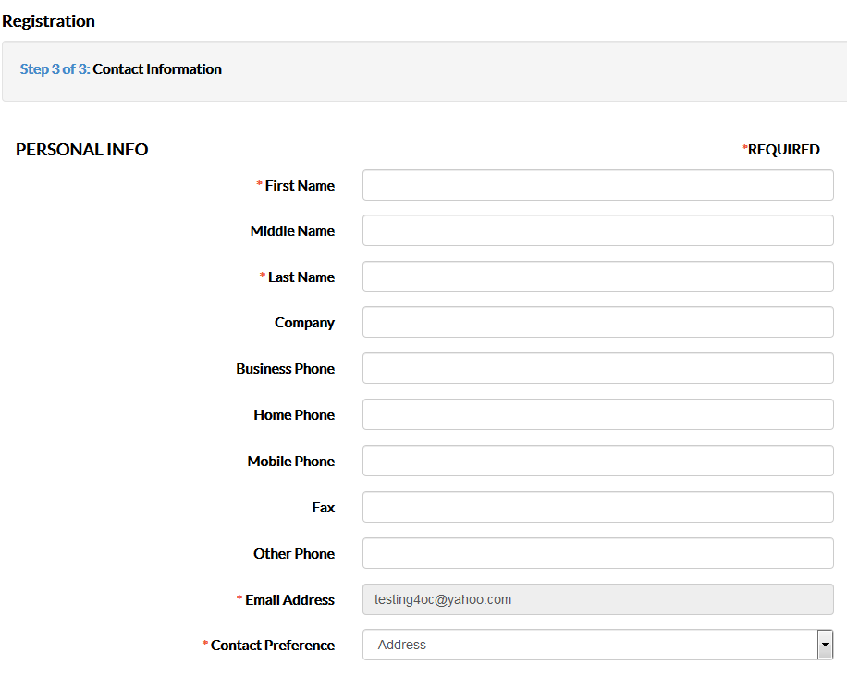
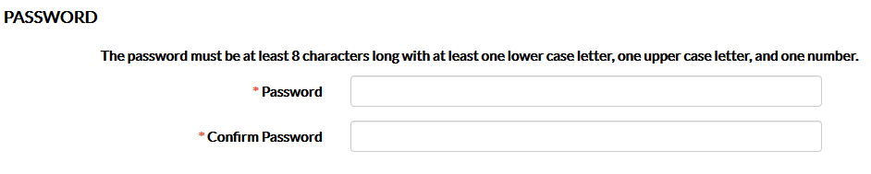
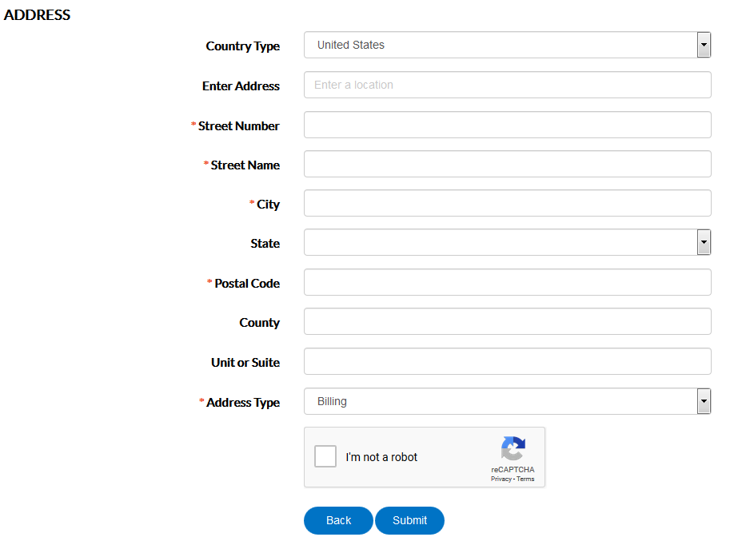
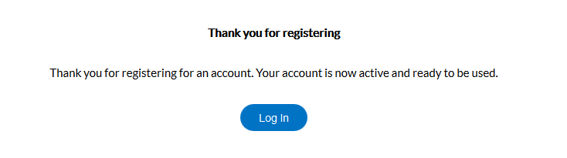

Once registration is complete, log in to your account to begin scheduling inspections:
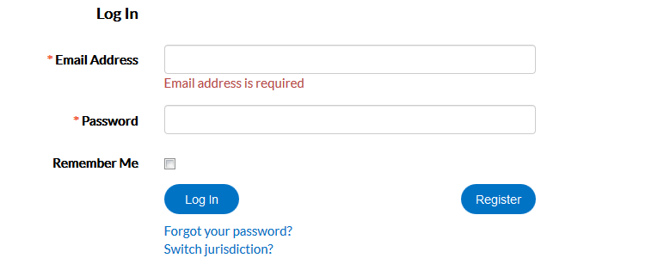

Scheduling Inspections
Click on the “Dashboard” tab to view Permits, Plans, Inspections and Invoices directly linked to your email account. Each email address linked to the submitted permit will have access to view and schedule inspections if the applicants have registered an account. Please list all of the applicable email addresses on the permit application at the time of submittal for individuals such as General Contractor/Owner, Electrical Contractor, Mechanical Contractor and Plumbing Contractor. These email addresses will also be used to email inspection results. Note: Permits will not populate under your Active Permits if your email is not directly related to the permit. Contact the Building Department to add your email account to your open permits.
My Permits
Select the “Active” circle to see a list of your active permits:
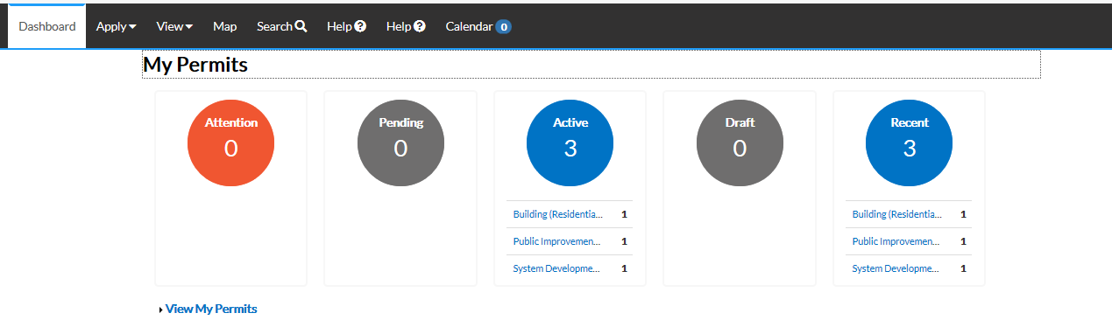
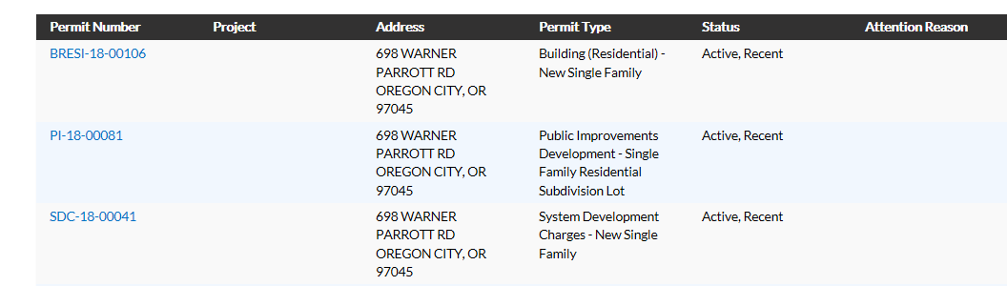

Select the permit number you would like to view:
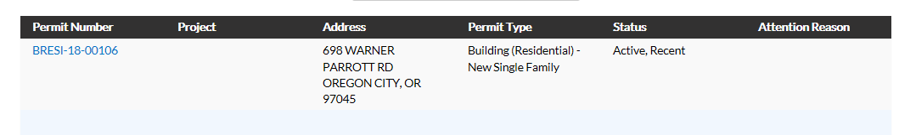
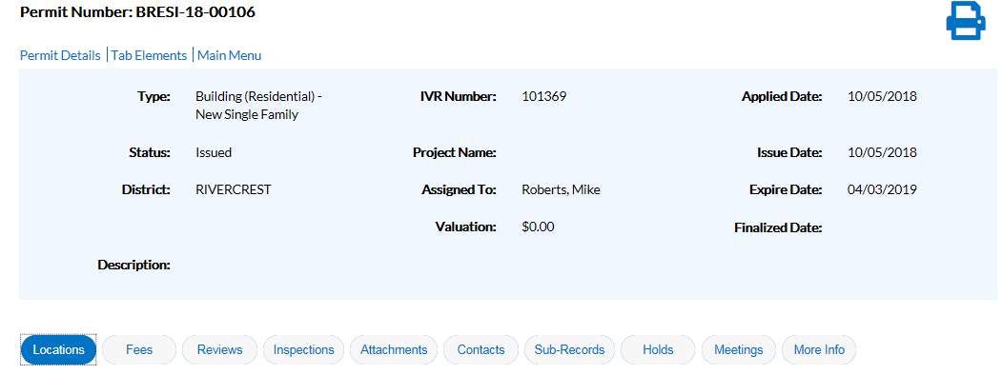
The “Inspections” tab located below your Permit Details will show you the available inspections on your permit. In our new system we currently have prerequisites. As you can see below, the following inspections must be selected and approved prior to the remaining inspections being available to schedule. If you feel this is incorrect for your permit, please contact the Building Department.
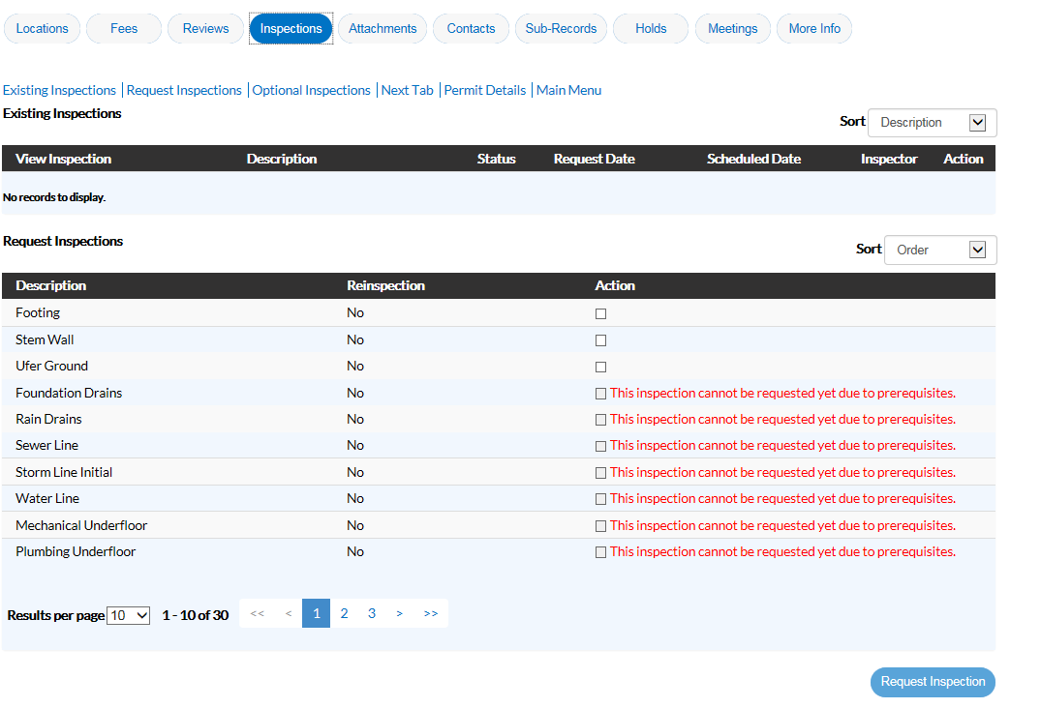

Request Inspections
Select the “Action” checkbox related to the inspection you are requesting and select “Request Inspection”.
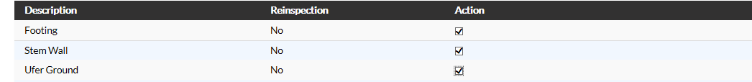
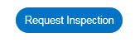
Each inspection will require attention. Input the date and comments directly related to each inspection if applicable. Note: We cannot always accommodate requests such as AM or PM. You may select “Use same date for all” inspections.
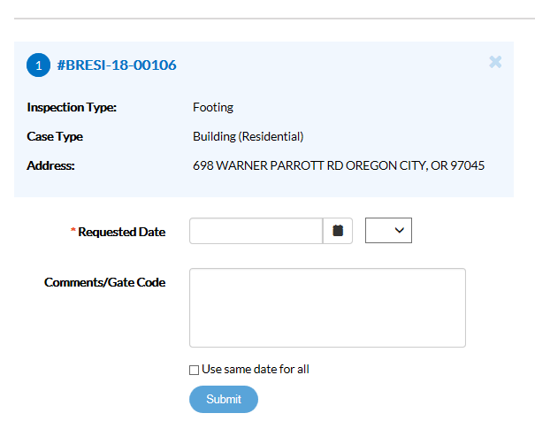

Each inspection requires you to select submit. You will see a green checkmark after each inspection has been submitted:
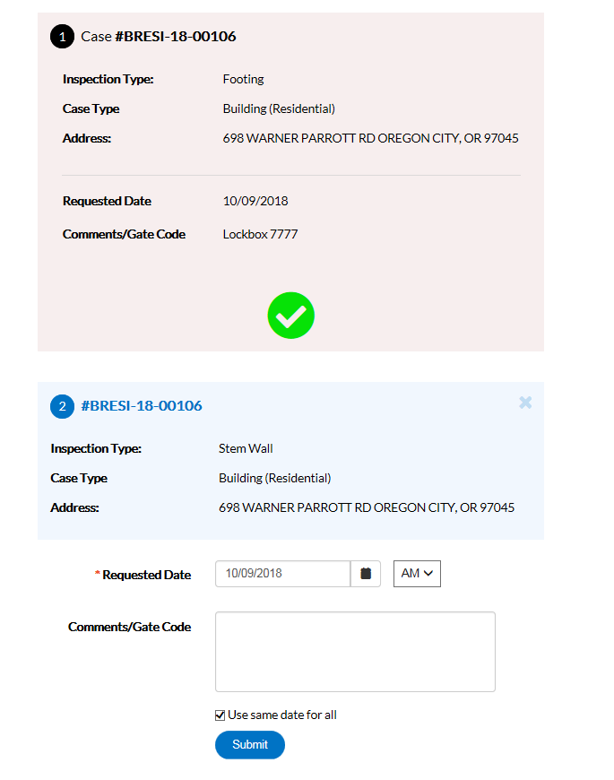
Input Comments and Select “Submit”
Submitted
Return to your “Dashboard” by selecting the “Dashboard” tab and scroll down to “My inspections” to view the requested inspections:
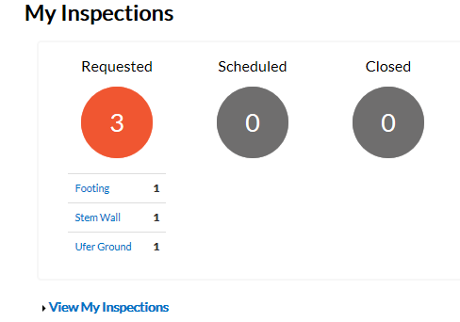

After the inspections are complete you will be able to view your inspection under “My inspections”, “Closed” inspections:
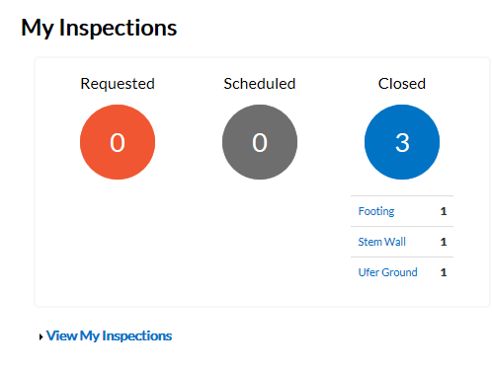
If the inspection was denied, a notification will come up under “My Permits” as an “Attention” item. Select the permit, select the “Inspections” tab, select the denied inspection and then select the “Checklist” tab to view the comments on the denied inspection. You will need to view each specific inspection under the “Inspections” tab for comments regarding the inspection. 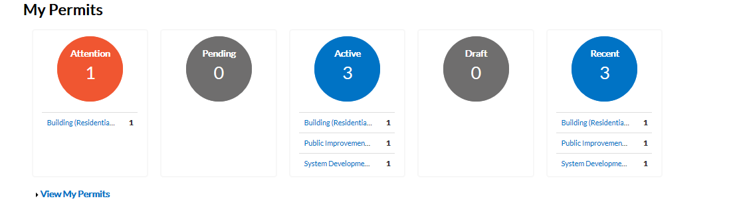
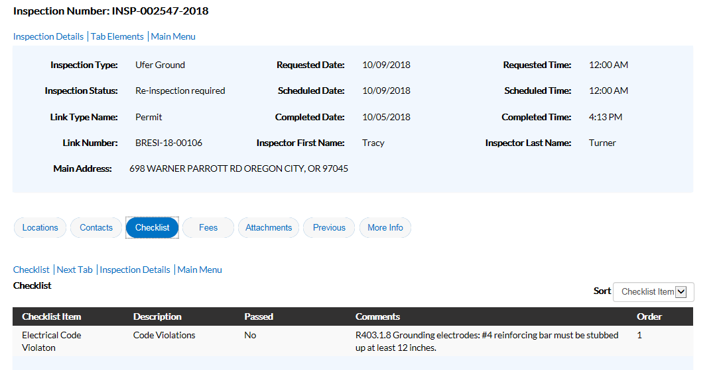
A re-inspection must be scheduled prior to moving on with your other inspections.
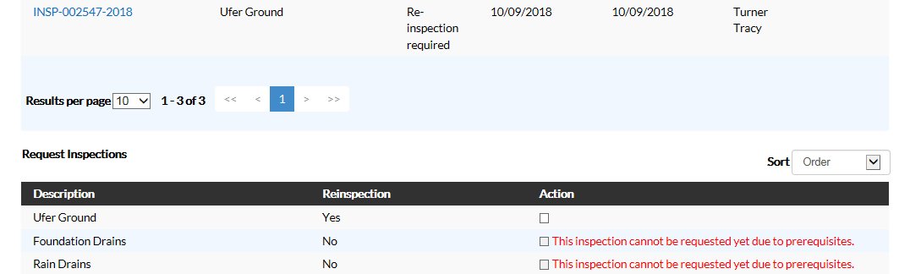

Re-inspections can be scheduled by going to the “Dashboard” and selecting your active permit. Select the “Inspections” tab and scroll down to “Request Inspections”. 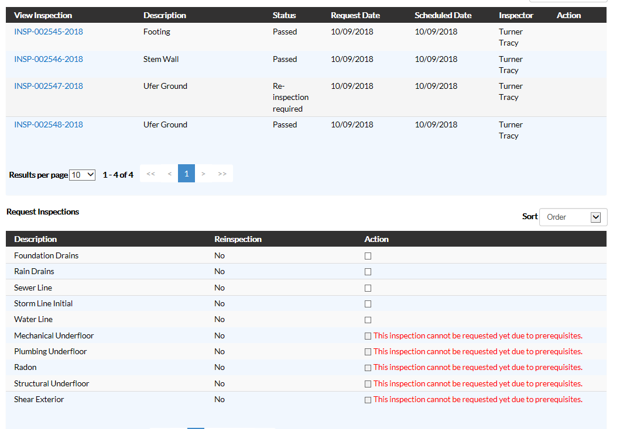

At this time, we are not accepting applications online or payments made online. Mobile devices can be used to schedule inspections.
Please let us know if you have any questions or encounter any problems.

Thank you,
Oregon City Building Department
698 Warner Parrott Rd
503-722-3789
permits@orcity.org

